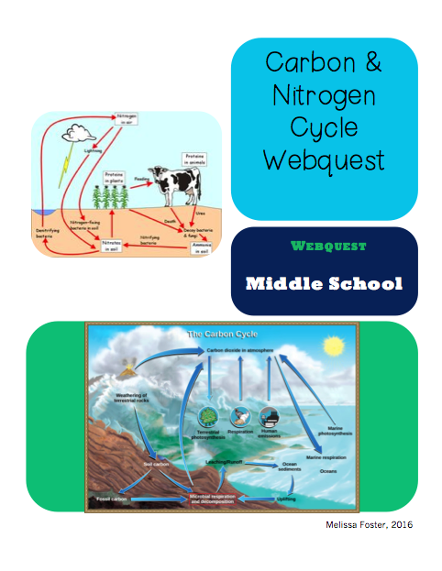

Biosphere, Carbon Cycle & Nitrogen Cycle Webquest

Directions: Before you begin:
- Click “File” then click “Make a Copy”
- Rename file by adding your name to it (Copy of Webquest: Your Name)
- Then follow directions below:
For each website below, click on the website name and then the website URL. Answer the questions below in a complete sentence or more. When finished with Website 3:
- Click the blue button “Share” at the top.
- Share with: (teacher’s email)
- Due:

Website 1: National Geographic’s Biosphere Explained
1. The biosphere is ________________________________________ that has ever existed in the entire universe. (Write the middle of this sentence below).

2. Scientists describe the Earth in terms of three spheres. Explain in 1-2 sentences what they are and give a real life living organism that resides in each.

3. Explain in one sentence, how many biosphere reserves are there in the world and give an example of one of these biosphere reserves.

Website 2: NOAA: Carbon Cycle
4. Where is most of Earth’s carbon located?

5. What are three human activities that cause an increase of carbon in our atmosphere.

6. In the top diagram, identify four ways carbon travels into the atmosphere. (Follow the up arrow).

7. Explain in 1-2 complete sentences how increased levels of CO2 in our oceans could hurt and endanger our marine life.

Website 3: Inhaling More CO2 than Exhaling

8. What has been the cause of early spring leafing in the United States?

9. Has this helped or hurt our atmosphere? Explain.

Website 4: The Nitrogen Cycle

10. If 21% of our atmosphere is oxygen and 78% of our atmosphere is nitrogen, are we able to attain our nitrogen levels in our body that we need through the air? Explain in a complete sentence.

11. In Figure 2, there are some plants like clover that can take nitrogen from the air and use it for plant growth. Explain how it does this in a complete sentence.

12. Explain in 2-3 complete sentences the process that puts nitrogen back into the atmosphere.

KEY

Website 1: National Geographic’s Biosphere Explained
1. The biosphere is ________________________________________ that has ever existed in the entire universe. (Write the middle of this sentence below).

The biosphere is simply the home of all known life that has ever existed in the entire universe.

2. Scientists describe the Earth in terms of three spheres. Explain in 1-2 sentences what they are and give a real life living organism that resides in each.

The three layers are lithosphere, hydrosphere, and atmosphere.
The lithosphere is the solid surface area; also known as the geosphere
The atmosphere is the layer of air that stretches above the lithosphere.
The hydrosphere is Earth’s water on the surface, in the ground, and in the air.
Answers will vary for organisms present in each

3. Explain in one sentence, how many biosphere reserves are there in the world and give an example of one of these biosphere reserves.

There are 563 biosphere reserves. The first biosphere reserve was in Yangambi, Democratic Republic of Congo. It has 32,000 species of trees and other species such as forest elephants and red river hogs. This reserve supports activities such as agriculture, hunting, and mining.
Website 2: NOAA: Carbon Cycle
4. Where is most of Earth’s carbon located?
Most of Earth’s carbon is stored in rocks and sediments.

5. What are three human activities that cause an increase of carbon in our atmosphere.
Burning fossil fuels, changing land use, and using limestone to make concrete all transfer significant quantities of carbon into the atmosphere.

6. In the top diagram, identify four ways carbon travels into the atmosphere. (Follow the up arrow).
1. Respiration
2. Exchange with the ocean
3. Burning of forests
4. Volcanoes

7. Explain in 1-2 complete sentences how increased levels of CO2 in our oceans could hurt and endanger our marine life.
It creates more acidity in the water that wears away animals with shells, like crabs, and destroys coral reefs.

Website 3: Inhaling More CO2 than Exhaling

8. What has been the cause of early spring leafing in the United States?
The warming of Earth’s overall temperature.

9. Has this helped or hurt our atmosphere? Explain.
In this case, early leafing is help Earth’s atmosphere because it’s giving more time for carbon dioxide to be taken out of the Earth’s atmosphere.
Website 4: The Nitrogen Cycle

10. If 21% of our atmosphere is oxygen and 78% of our atmosphere is nitrogen, are we able to attain our nitrogen levels in our body that we need through the air? Explain in a complete sentence.

No, we are not able to get it from the air because air is N2 gas. The nitrogen that is cycled throughout the nitrogen cycle are nitrates and nitrites. The nitrogen our body needs is unable to be converted from N2 gas.

11. In Figure 2, there are some plants like clover that can take nitrogen from the air and use it for plant growth. Explain how it does this in a complete sentence.

Clovers can take nitrogen from the air by certain bacteria, including those among the genus rhizobium, are able to fix nitrogen through metabolic processes, analogous to the way mammals convert oxygen to CO2 when they breathe.

12. Explain in 2-3 complete sentences the process that puts nitrogen back into the atmosphere.
The process that puts nitrogen back into the atmosphere is denitrification. This process works by nitrogen such as nitrate and nitrite are converted into dinitrogen or nitrous oxide gas. After it is converted into dinitrogen it gets lost into the atmosphere because it is a gas.

